EXPERIMENT- 16
Perform Edge Detection using Canny Method
Aim
To write a Python code to detect edges in an image using the Canny edge detection method in OpenCV for identifying object boundaries.
Input Image

Code
import cv2
from google.colab.patches import cv2_imshow
from google.colab import files
uploaded=files.upload()
image_path=list(uploaded.keys())[0]
image=cv2.imread(image_path)
if image is None:
print("Error: Image not found")
else:
gray=cv2.cvtColor(image,cv2.COLOR_BGR2GRAY)
blurred=cv2.GaussianBlur(gray,(5,5),0)
edges=cv2.Canny(blurred,100,200)
print("Original Image")
cv2_imshow(image)
print("Canny Edge Image")
cv2_imshow(edges)
Output Image
Canny Edge Image
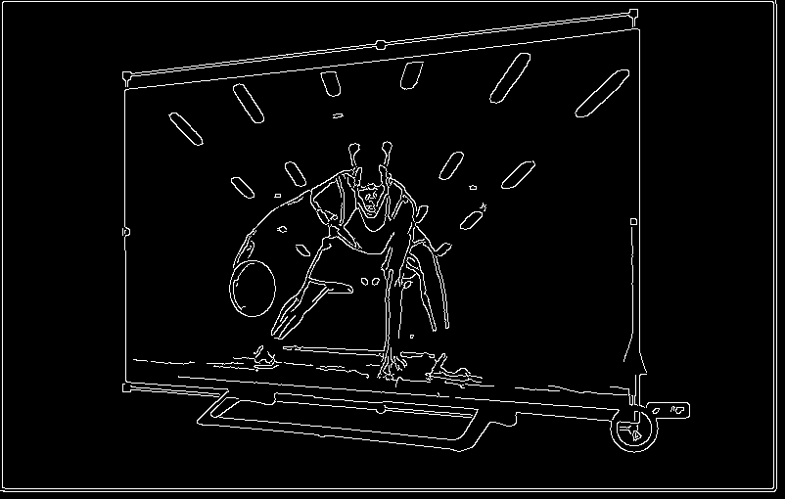
Result
Thus, edges were successfully detected using the Canny edge detection method in OpenCV.

